# Project: Biking in Kansas and Alaska Name:_________________

Math A104

In this project, we’re going to think about what makes a relationship linear or not linear. Each question is worth two points.

1. This is a graph of a linear relationship. Looking at it, what about it tells you that it is linear? 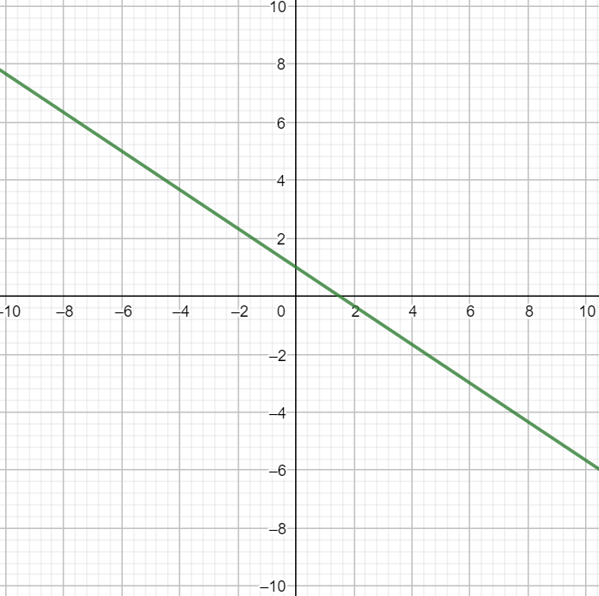
2. Here is a table of some of the points represented on the above graph. This data also represents a linear relationship. Without graphing, how can you tell that this relationship is linear?

|  |  |
| --- | --- |
|  |  |
|  |  |
|  |  |
|  |  |
|  |  |

Friends Jacob and Mike like to bike. For a math conference, the two traveled to Kansas and decided to go on a bike ride one evening. Mike enjoys tracking his data and so took note of his distance traveled at regular intervals. Here is a table of Mike’s time and mileage:

|  |  |
| --- | --- |
|  |  |
|  |  |
|  |  |
|  |  |
|  |  |

1. Does this table represent a linear relationship? Give some supporting computations OR write a sentence to support your answer.

Jacob is more absent minded in tracking his mileage over time, and so took note of his distance traveled sporadically. Here is a table of Jacob’s time and mileage:

|  |  |
| --- | --- |
|  |  |
|  |  |
|  |  |
|  |  |
|  |  |

1. Does this table represent a linear relationship? Give some supporting computations OR write a sentence to support your answer.

After returning home to Alaska, the friends decide to go on another ride. This bike ride was on a trail in the foothills of the Chugach Mountains. Again, Mike took note of his distance traveled at regular intervals Here is a table of Mike’s time and mileage:

|  |  |
| --- | --- |
|  |  |
|  |  |
|  |  |
|  |  |
|  |  |

1. Does this table represent a linear relationship? Give some supporting computations OR write a sentence to support your answer.

Again, Jacob is absent minded in tracking his mileage over time, and so took note of his distance traveled sporadically. Here is a table of Jacob’s time and mileage:

|  |  |
| --- | --- |
|  |  |
|  |  |
|  |  |
|  |  |
|  |  |

1. Does this table represent a linear relationship? Give some supporting computations OR write a sentence to support your answer.
2. Slope is $\frac{change in y values}{change in x values}$. If the first columns of the four tables above represent $x$ values and the second columns represent $y$ values, find the unit of the slope. Your answer should be a *unit*, like $\frac{ft}{s}$ or $in^{2}$, **not a number**.
3. (1 point extra credit): Consider your answer to the previous question. What does this unit represent? Your answer can be one word.